TPG-Net Inference
Text-to-image:
1.slow_down_GWHL_IMG_5559.jpg
Captions: In a real road traffic intersection environment, with the officer appearing as a small full figure in the center. From my left, I observe a traffic police officer signaling to slow down (The officer indicates that vehicles should slow down by raising the right arm straight upward, palm facing down, giving a clear gesture to reduce speed); he is wearing a green vest, a white shirt, and is wearing a hat.
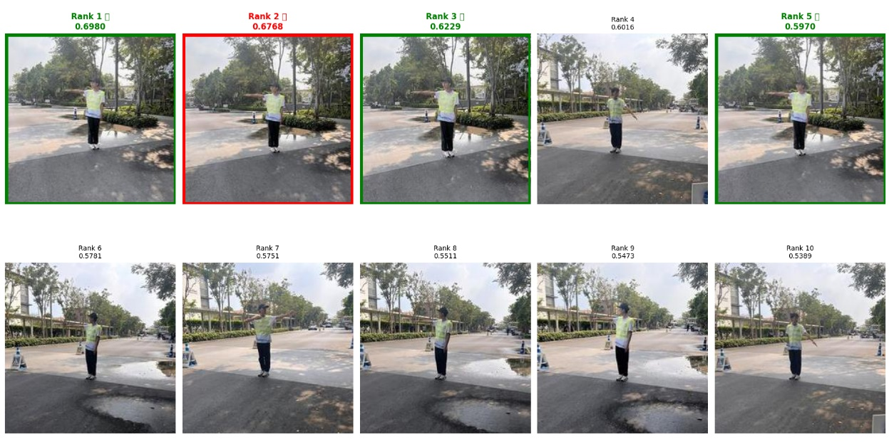
2.change_lane_RWHR_IMG_4888.jpg
Captions: In a real road traffic intersection environment, with a maximum-scale full-length view. Directing traffic by signaling to change lane (The officer signals a lane change by raising the right arm diagonally to the side, palm facing inward toward the body, while looking straight ahead to guide the driver into the adjacent lane) from my right is an officer in a red vest and a white shirt, and he is wearing a hat.
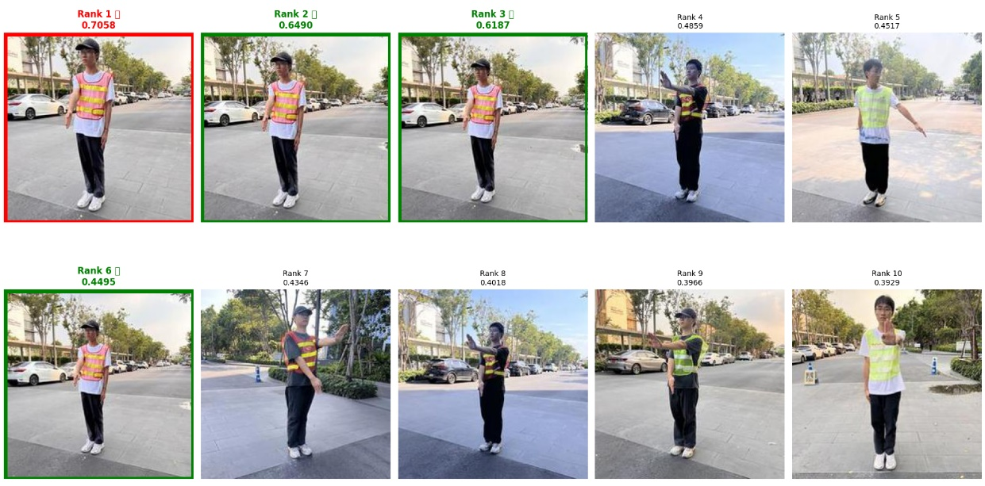
3.turn_right_RBHR_IMG_E3489.JPG
Captions: In a real road traffic intersection environment, showing a tiny full-body figure in the middle. A traffic police officer is signaling to turn right (For a right turn, the officer extends the right arm straight out to the right side with the palm facing right, raises the left arm upward at an angle, and looks right toward the direction of the turn) on my right, wearing a red vest and a black shirt, and he is wearing a hat.
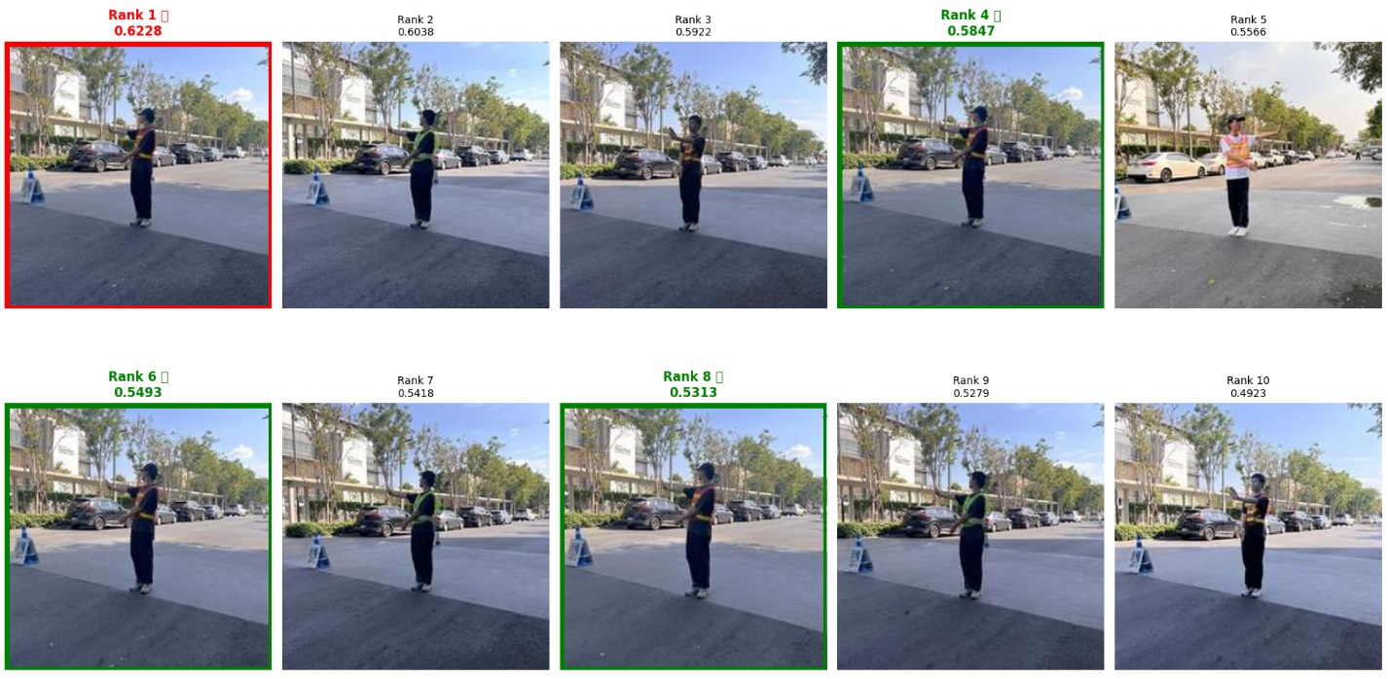
4.go_straight_GBHL_IMG_E3853.JPG
Captions: In a real road traffic intersection environment, with a smaller full-length view of the officer. There, on my left, a traffic police officer wearing a green vest and a black shirt, wearing a hat, is signaling to go straight (To signal vehicles to go straight, the officer stretches both arms out horizontally to the sides, keeping them parallel to the ground and palms facing forward, and turns the head to look left).
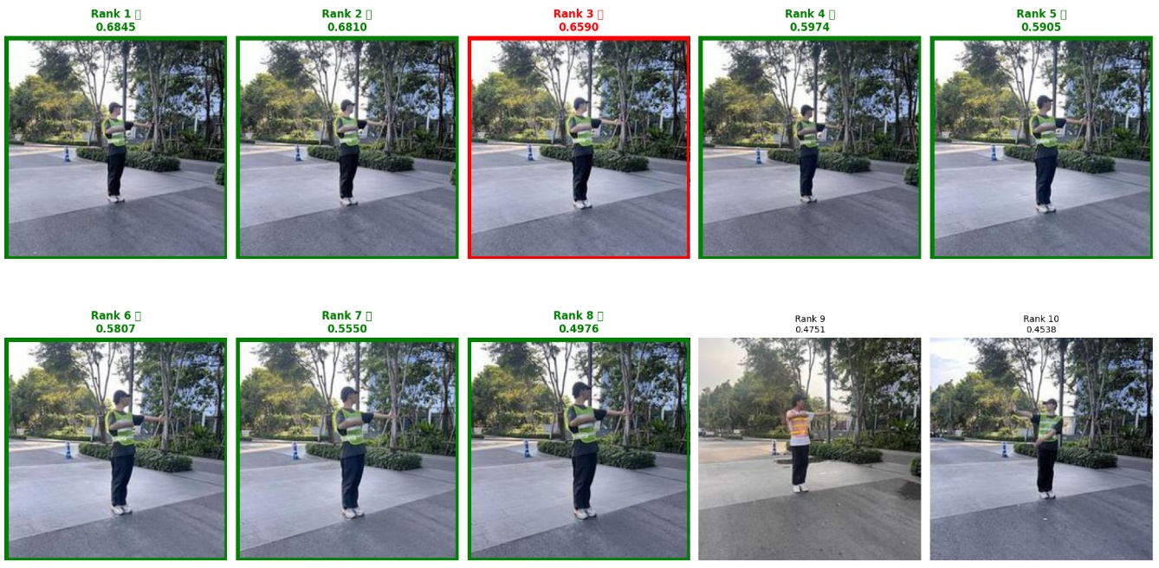
5.pull_over_RBHL_IMG_E3737.JPG
Captions: In a real road traffic intersection environment, with the full-length officer appearing closely. On my left stands a traffic police officer, wearing a hat, signaling to pull over (To order a vehicle to pull over and stop by the roadside, the officer extends the left arm straight forward with the palm facing forward, raises the right arm at an angle, and looks straight ahead) and dressed in a red vest with a black shirt underneath.
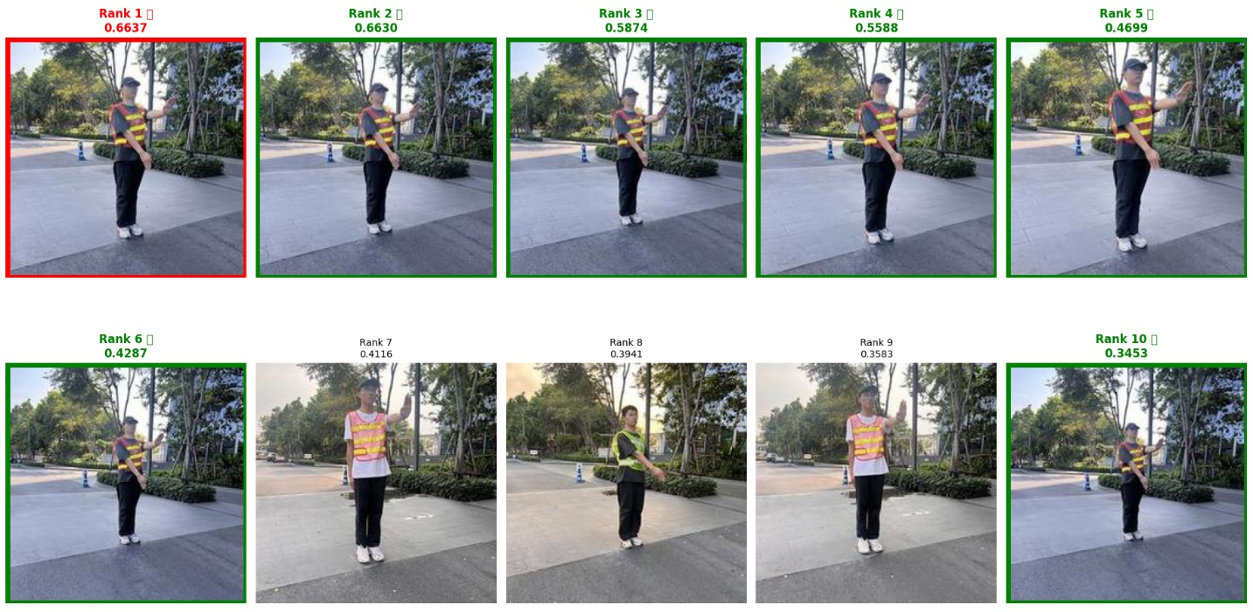
6.change_lane_GBNL_IMG_E4169.JPG
Captions: In a real road traffic intersection environment, with a maximum-scale full-length view. Directing traffic by signaling to change lane (The officer signals a lane change by raising the right arm diagonally to the side, palm facing inward toward the body, while looking straight ahead to guide the driver into the adjacent lane) from my left is an officer in a green vest and a black shirt, and he is not wearing a hat.
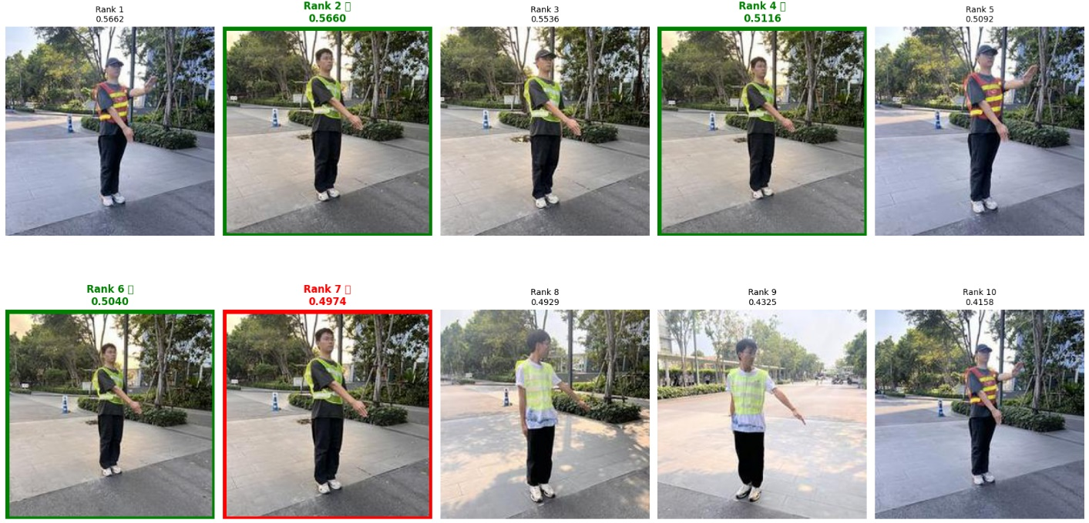
7.change_lane_RWHR_IMG_4881.jpg
Captions: In a real road traffic intersection environment, with the full-body officer surrounded by wide margins. Signaling to change lane (The officer signals a lane change by raising the right arm diagonally to the side, palm facing inward toward the body, while looking straight ahead to guide the driver into the adjacent lane) from my right is a traffic police officer in a white shirt and a red vest, and he is wearing a hat.
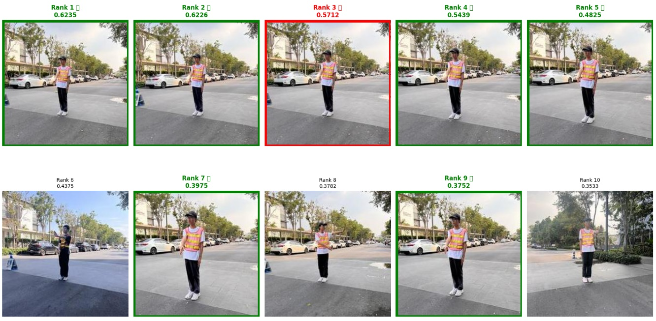
8.stop_GWHL_IMG_5086.jpg
Captions: In a real road traffic intersection environment, with the full-body officer surrounded by wide margins. Signaling to stop (The traffic officer extends the left arm straight forward and upward at an angle, with the palm facing forward and fingers together, while fixing their eyes straight ahead to command approaching vehicles to stop) from my left is a traffic police officer in a white shirt and a green vest, and he is wearing a hat.
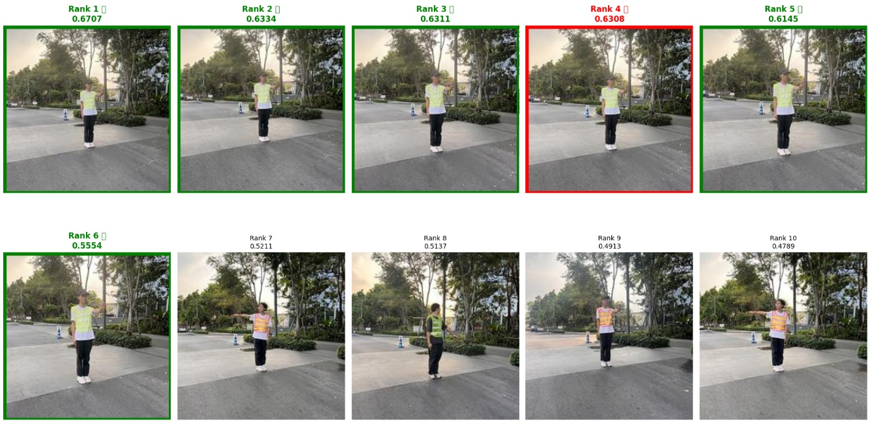
9.go_straight_GWHR_IMG_5189.jpg
Captions: In a real road traffic intersection environment, with the officer's full body entirely filling the vertical frame. My right offers a view of a traffic police officer who is wearing a hat, wearing a green vest and a white shirt, and performing a go straight (To signal vehicles to go straight, the officer stretches both arms out horizontally to the sides, keeping them parallel to the ground and palms facing forward, and turns the head to look left) signal.
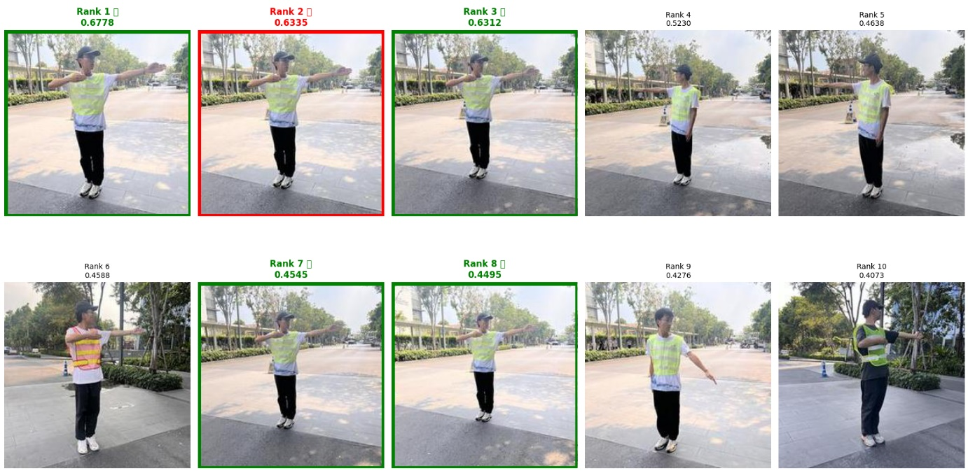
10.go_straight_GBHL_IMG_E3850.JPG
Captions: In a real road traffic intersection environment, with the officer appearing as a small full figure in the center. From my left, I observe a traffic police officer signaling to go straight (To signal vehicles to go straight, the officer stretches both arms out horizontally to the sides, keeping them parallel to the ground and palms facing forward, and turns the head to look left); he is wearing a green vest, a black shirt, and is wearing a hat.
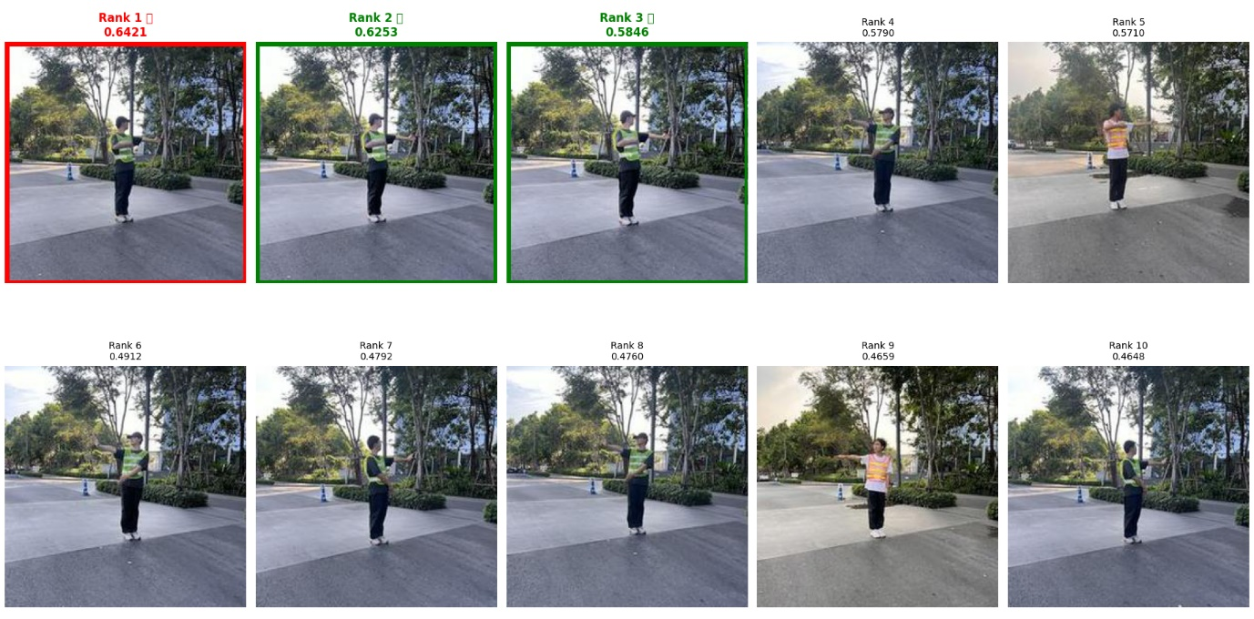
11.slow_down_RWNL_IMG_4912.jpg
Captions: In a real road traffic intersection environment, with a well-proportioned full-length view. In my view on left, a traffic police officer, not wearing a hat, is signaling to slow down (The officer indicates that vehicles should slow down by raising the right arm straight upward, palm facing down, giving a clear gesture to reduce speed) while wearing a red vest and a white shirt.
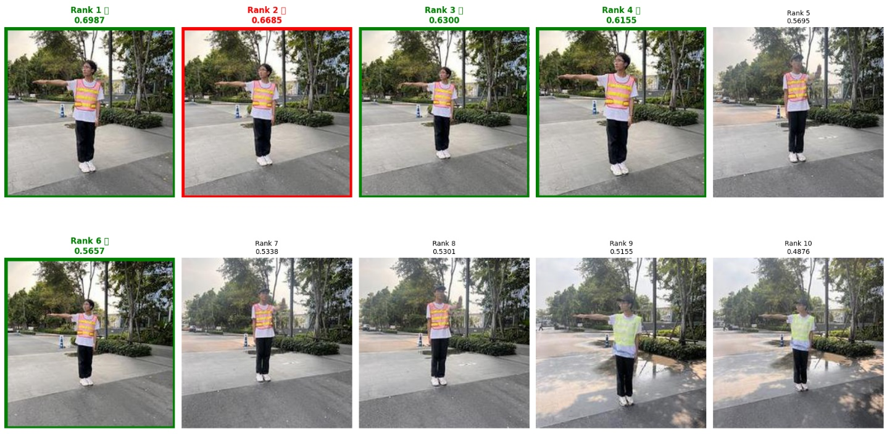
12.pull_over_GBHR_IMG_E4320.JPG
Captions: In a real road traffic intersection environment, with the officer appearing as a small full figure in the center. From my right, I observe a traffic police officer signaling to pull over (To order a vehicle to pull over and stop by the roadside, the officer extends the left arm straight forward with the palm facing forward, raises the right arm at an angle, and looks straight ahead); he is wearing a green vest, a black shirt, and is wearing a hat.
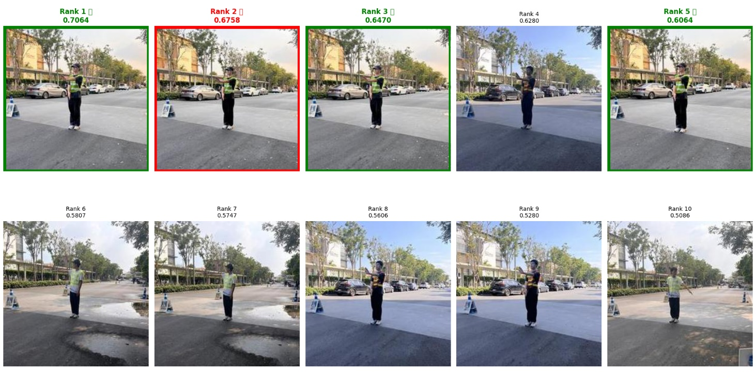
13.wait_to_turn_left_GWNR_IMG_5371.jpg
Captions: In a real road traffic intersection environment, with the full-body officer surrounded by wide margins. Signaling to wait to turn left (To instruct a driver to wait and prepare for a left turn, the officer raises the left arm downward at an angle, palm facing down, and looks left toward the waiting area) from my right is a traffic police officer in a white shirt and a green vest, and he is not wearing a hat.
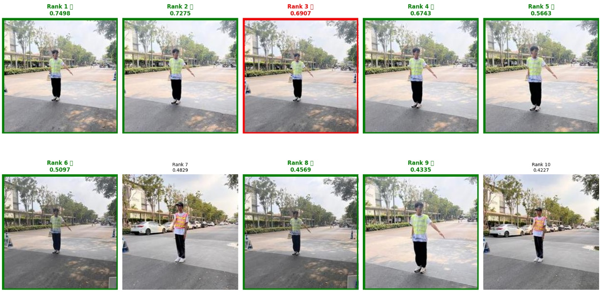
14.turn_left_GBNL_IMG_E3890.JPG
Captions: In a real road traffic intersection environment, with the officer appearing as a small full figure in the center. From my left, I observe a traffic police officer signaling to turn left (When directing a left turn, the officer extends the left arm straight out to the left side with the palm facing left, raises the right arm upward at an angle, and looks left toward the turning direction); he is wearing a green vest, a black shirt, and is not wearing a hat.
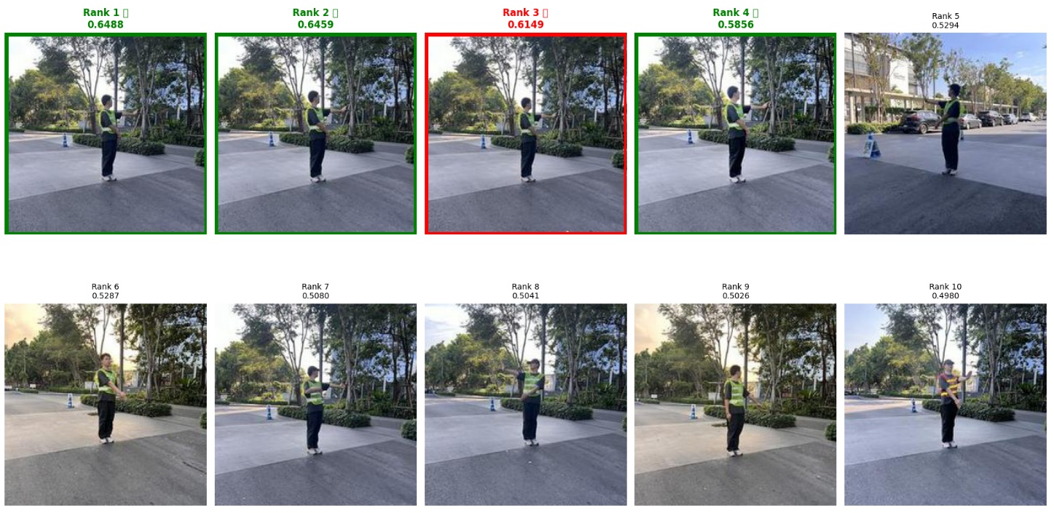
15.wait_to_turn_left_GWNR_IMG_5376.jpg
Captions: In a real road traffic intersection environment, with the full-length officer appearing closely. On my right stands a traffic police officer, not wearing a hat, signaling to wait to turn left (To instruct a driver to wait and prepare for a left turn, the officer raises the left arm downward at an angle, palm facing down, and looks left toward the waiting area) and dressed in a green vest with a white shirt underneath.
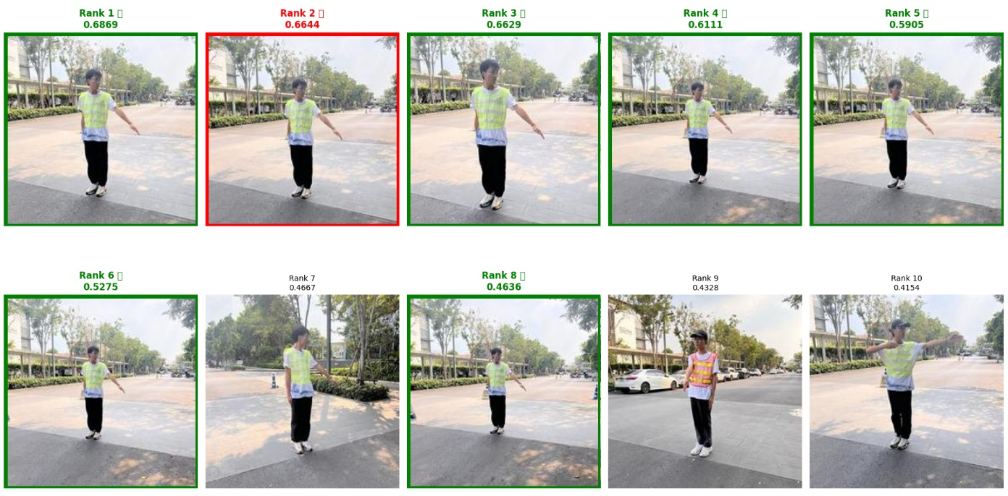
16.pull_over_RBNR_IMG_E3717.JPG
Captions: In a real road traffic intersection environment, with the full-length officer appearing closely. On my right stands a traffic police officer, not wearing a hat, signaling to pull over (To order a vehicle to pull over and stop by the roadside, the officer extends the left arm straight forward with the palm facing forward, raises the right arm at an angle, and looks straight ahead) and dressed in a red vest with a black shirt underneath.
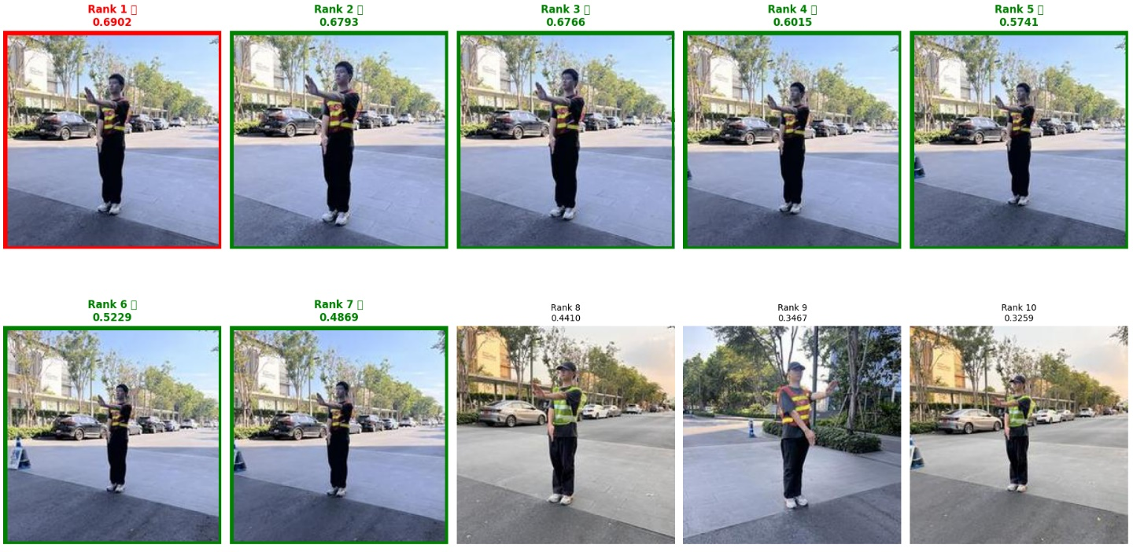
17.turn_right_GBNR_IMG_E3976.JPG
Captions: In a real road traffic intersection environment, with the full-body officer at a standard moderate scale. I see an officer on my right signaling to turn right (For a right turn, the officer extends the right arm straight out to the right side with the palm facing right, raises the left arm upward at an angle, and looks right toward the direction of the turn); his uniform consists of a black shirt under a green vest, and he is not wearing a hat.
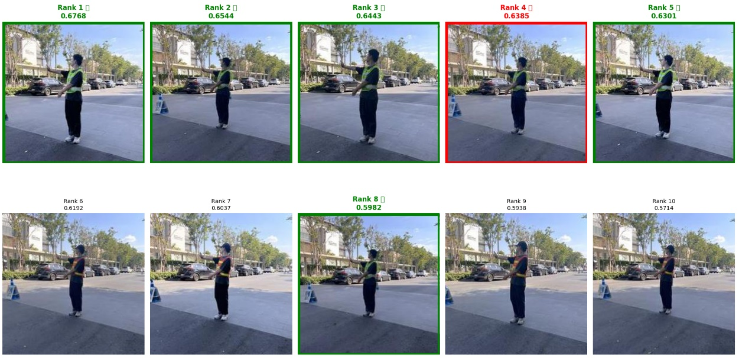
18.slow_down_GWHR_IMG_5576.jpg
Captions: In a real road traffic intersection environment, with the full-length officer appearing closely. On my right stands a traffic police officer, wearing a hat, signaling to slow down (The officer indicates that vehicles should slow down by raising the right arm straight upward, palm facing down, giving a clear gesture to reduce speed) and dressed in a green vest with a white shirt underneath.
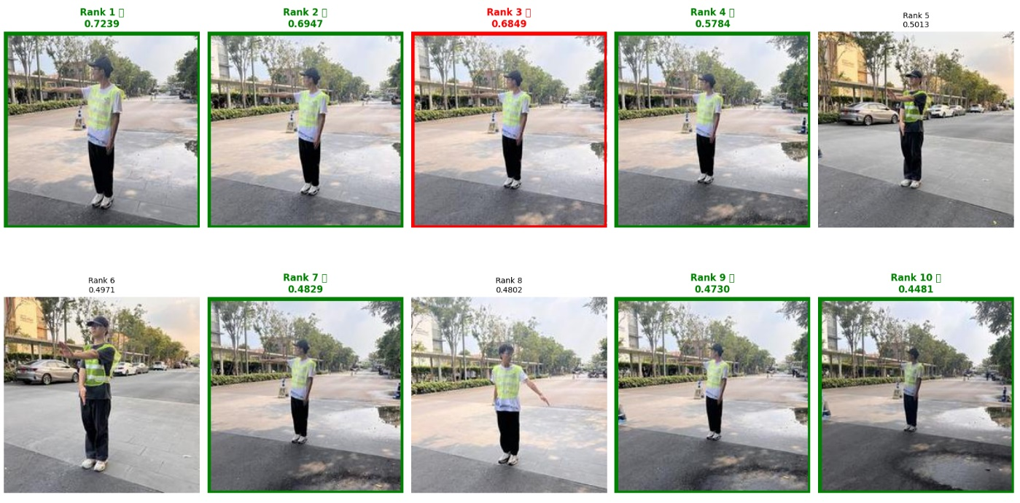
19.turn_right_GBHL_IMG_E4002.JPG
Captions: In a real road traffic intersection environment, with a maximum-scale full-length view. Directing traffic by signaling to turn right (For a right turn, the officer extends the right arm straight out to the right side with the palm facing right, raises the left arm upward at an angle, and looks right toward the direction of the turn) from my left is an officer in a green vest and a black shirt, and he is wearing a hat.
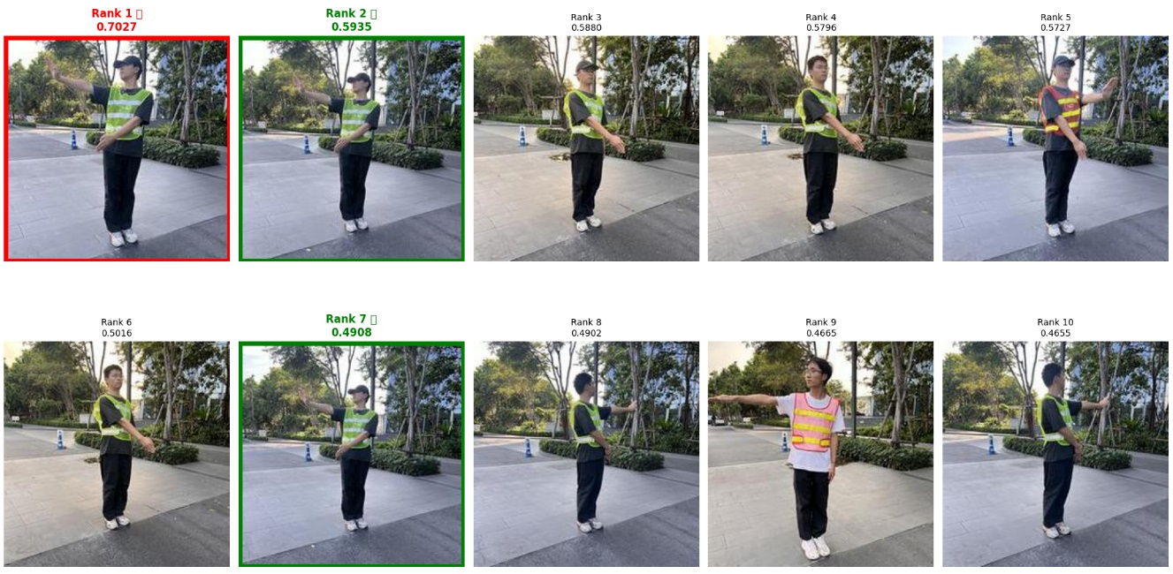
20.turn_left_RWHR_IMG_4687.jpg
Captions: In a real road traffic intersection environment, with the officer's full body entirely filling the vertical frame. My right offers a view of a traffic police officer who is wearing a hat, wearing a red vest and a white shirt, and performing a turn left (When directing a left turn, the officer extends the left arm straight out to the left side with the palm facing left, raises the right arm upward at an angle, and looks left toward the turning direction) signal.
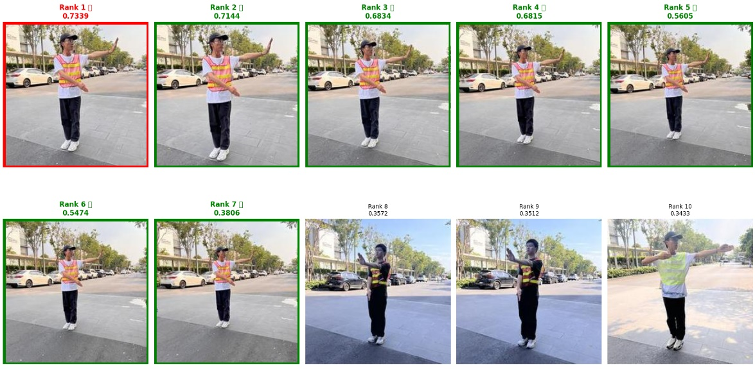
21.change_lane_GBNL_IMG_E4168.JPG
Captions: In a real road traffic intersection environment, with the officer's full body entirely filling the vertical frame. My left offers a view of a traffic police officer who is not wearing a hat, wearing a green vest and a black shirt, and performing a change lane (The officer signals a lane change by raising the right arm diagonally to the side, palm facing inward toward the body, while looking straight ahead to guide the driver into the adjacent lane) signal.
